

Darshan University

A Project Report on

“Auction Management System”

Under the subject

Software Engineering (2301CS405)

B. Tech, Semester – IV

Computer Science & Engineering Department

Submitted By
Student Name: Dhruv R. Pithwa | Enrolment No.: 24010101675
Academic Year
(2024-2025)
Internal Guide  Prof. R. B. Gondaliya  Darshan University | Dean-DIET  Dr. Gopi Sanghani  Darshan University

 | Computer Science & Engineering Department  Darshan University

DECLARATION

We hereby declare that the SRS, submitted along with the Software Engineering (2301CS405) for entitled “Auction Management System” submitted in partial fulfilment for the Semester-5 of Bachelor Technology (B. Tech) in Computer Science and Engineering (CSE) Department to Darshan University, Rajkot, is a record of the work carried out at Darshan University, Rajkot under the supervision of R. B. Gondaliya and that no part of any of report has been directly copied from any students’ reports, without providing due reference.

Dhruv R. Pithwa

Student’s Signature

Date: __________

 | Computer Science & Engineering Department  Darshan University

CERTIFICATE

This is to certify that the SRS on “Auction Management System” has been satisfactorily prepared by Dhruv R. Pithwa (24010101675) under my guidance in the fulfillment of the course Software Engineering (2301CS405) work during the academic year 2024-2025.

Internal Guide  Prof. R. B. Gondaliya  Darshan University |  | Dean-DIET  Dr. Gopi Sanghani  Darshan University

Acknowledgement
I wish to express my sincere gratitude to my project guide Prof. R. B. Gondaliya and all the faculty members for helping me through my project by giving me the necessary suggestions and advices along with their valuable co- ordination in completing this work.

I also thank my parents, friends and all the members of the family for their precious support and encouragement which they had provided in completion of my work. In addition to that, I would also like to mention the Darshan University personals who gave me the permission to use and experience the valuable resources required for the project from the University premises.

Thus, in conclusion to the above said, I once again thank the faculties and members of Darshan University for their valuable support in completion of the project.

Thanking You
Dhruv R. Pithwa

ABSTRACT
Library management system is a system which aims in developing a computerized system to maintain all the daily work of library. This system will act as a tool to transfer traditional library into digital library. This project has many features which are generally not available in general library system like facility of user login, books search on one click etc. It also has a facility of admin login through which the admin can monitor the whole system. This system will be designed with the basic features such as librarian can add/view/update/delete books and students' details in it. It has also a facility where student after logging in their accounts can see list of books issued and its issue date and return date and also they can request the librarian to add new books by filling the book request form. The librarian after logging into his account i.e. admin account can generate various reports such as student report , issue report, teacher report and book report.

Main purpose of this system is to reduce human efforts as much as possible.

Table of Contents
List of Figures I
List of Tables II
1 Introduction 1
1.1 Product perspective 1
1.2 Product features 1
1.2.1 There are three different users who will be using this product: 1
1.2.2 The features that are required for the Librarian are: 1
1.2.3 The features that are required for the Member are: 1
1.3 Functional Requirement 1
1.3.1 Librarian 1
1.3.2 Member 2
1.4 Non-Functional Requirement 2
1.4.1 Usability: 2
1.4.2 Accuracy: 2
1.4.3 Availability: 2
1.4.4 Maintainability: 2
2 Design and Implementation Constraints 3
2.1 Use case diagram 3
2.2 Activity diagram and Swimlane diagram 4
2.3 Sequence diagram 5
2.4 State diagram 6
2.5 Class diagram 7
2.6 Data flow diagram 8
2.6.1 Context diagram (level-0) 8
2.6.2 DFD Level-1 8
2.6.3 DFD Level-2 9
3 External interface requirement (Screens) 10
3.1 Screen-1: Registration Form 10
3.2 Screen-2: Login Form 11
3.3 Screen-3: Add borrower book 12
4 Database design 13
4.1 List of Tables 13
5 Stories and Scenario 14
5.1 Story-1: Add New Book in Library Catalogue 14
5.1.1 Scenario# S1.1 14
5.1.2 Scenario# S1.2 14
5.1.3 Scenario# S1.3 14
5.2 Story-2: Search Book 15
5.3 Story-3: Manage due date for borrowed book 15
5.4 Story-4: Renew book 15
5.5 Story-5: Generate a report on book usage and availability 15
6 Test cases 16
7 References 20

List of Figures
Figure 2.1-1 Use case diagram for library management system 3
Figure 2.2-1 Activity diagram for Book Issue 4
Figure 2.2-2 Swimlane diagram for Book Issue 4
Figure 2.3-1 Sequence diagram for Book Issue 5
Figure 2.4-1 State diagram of Book 6
Figure 2.4-2 State diagram for Librarian 6
Figure 2.5-1 Class diagram for Library management system 7
Figure 2.6-1 Context diagram for Library management system 8
Figure 2.6-2 DFD level-1 for Library management system 8
Figure 2.6-3 DFD level-2 for Issue book 9
Figure 3.1-1 Screen-1: Registration Form 10
Figure 3.2-1 Screen-2: Login Form 11
Figure 3.3-1 Screen-3: Add borrower book 12

List of Tables

Table 3.1-1 Screen element of Registration form 10
Table 3.2-1 Screen element of Login form 11
Table 3.3-1 Screen element of Add borrower book 12
Table 4.1-1 Table: Book 13
Table 4.1-2 Table: Borrower 13
Table 4.1-3 Table: Staff 13
Table 4.1-4 Table: Student 13

Introduction

Product perspective

This project is basically updating the manual library system into an internet-based application so that the users can know the details of their account, availability of books etc. It is a multi-user version and can take care of all the fundamental functions of a Library like Cataloguing, Circulation, Accessioning and Housekeeping. It can satisfactorily cater to all the basic functions of a small library.

Product features

There are three different users who will be using this product:
- Librarian who will be acting as the administrator.
- Member who will be accessing the library.
- Guest who will request for membership.

The features that are required for the Librarian are:
- Control the movement of books and other material and avoid losing the same.
- Search if you have a specific book in your collection based on the title, author etc.
- Print the spine labels for the book.
- Find what a specific person has borrowed from you. It offers the following modules Cataloguing, Circulation, and Queries.
- Can issue a book to the student.
- Can view the list of books available in each category.
- Can take the book returned from students.
- Add books and their information of the books to the database.
- Edit the information of the existing books.
- Can check the report of the issued Books.
- Can access all the accounts of the students.

The features that are required for the Member are:
- Can view the different categories of books available in the library.
- Can view the List of books available in each category.
- Can own an account in the library.
- Can view the books issued to him.
- Can put a request for a new book.

Functional Requirement

Librarian
- Add Article: New entries must be entered in database
- Update Article: Any changes in articles should be updated in case of update3.
- Delete Article: Wrong entry must be removed from system
- Membership management: To maintain a detailed database of the members. The system records the name, ID and password of each user. The system helps in ascertaining the track record of the member.
- Bar-coding: To give specific identification to each book. All books, old and new, are bar-coded on the basis of title, author, topic and date of publishing.
- Barcode scanning: To read the barcode easily using RFID sensors. The database is automatically updated when books are scanned while issuing or returning.
- Search function: to enable both the librarian and the members to search the catalog of books in the library. The search functions can be filtered to the need of each user.
- Check out Article: To issue any article must be checked out
- Check In article: After receiving any article system will renter article by Checking
- Reserve Article: This use case is used to reserve any book with the name of librarian, it can be pledged.
- Set user Permission: From this user case Librarian can give permission categorically, also enabling/disabling of user permission can be set through this use case

Member
- Authentication: User must be authenticated before accessing system
- Search Article: User can search any article
- Request Article: After successful searching member mark this book as requested article
- Check Account: This use case is used to check account details

Non-Functional Requirement

Usability:
- The UI should be simple enough for everyone to understand and get the relevant information without any special training. Different languages can be provided based on the requirements.

Accuracy:
- The data stored about the books and the fines calculated should be correct, consistent, and reliable.

Availability:
- The System should be available for the duration when the library operates and must be recovered within an hour or less if it fails. The system should respond to the requests within two seconds or less.

Maintainability:
- The software should be easily maintainable and adding new features and making changes to the software must be as simple as possible. In addition to this, the software must also be portable.

Design and Implementation Constraints

Use case diagram

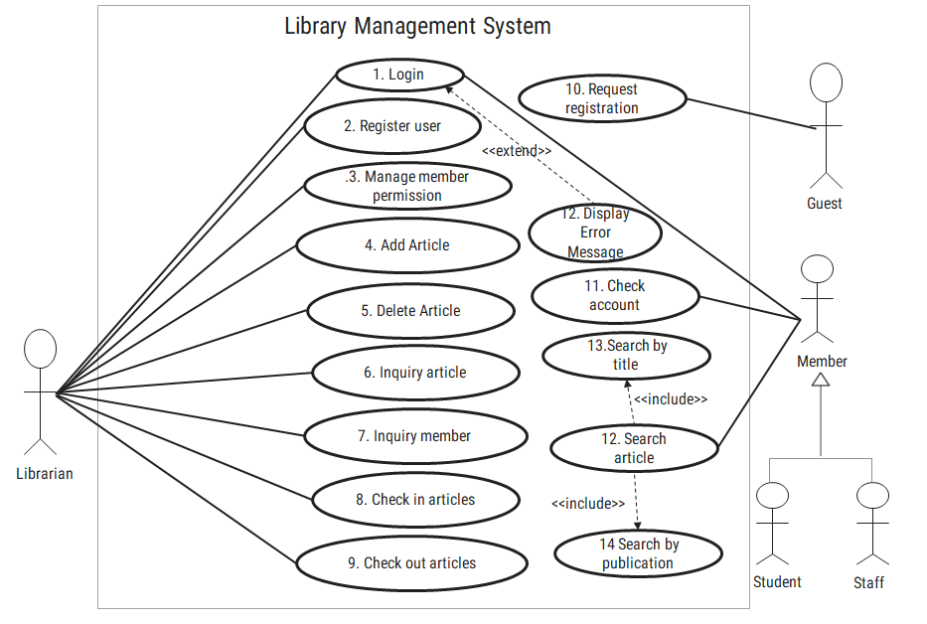
Figure Use case diagram-1 Use case diagram for library management system

Activity diagram and Swimlane diagram

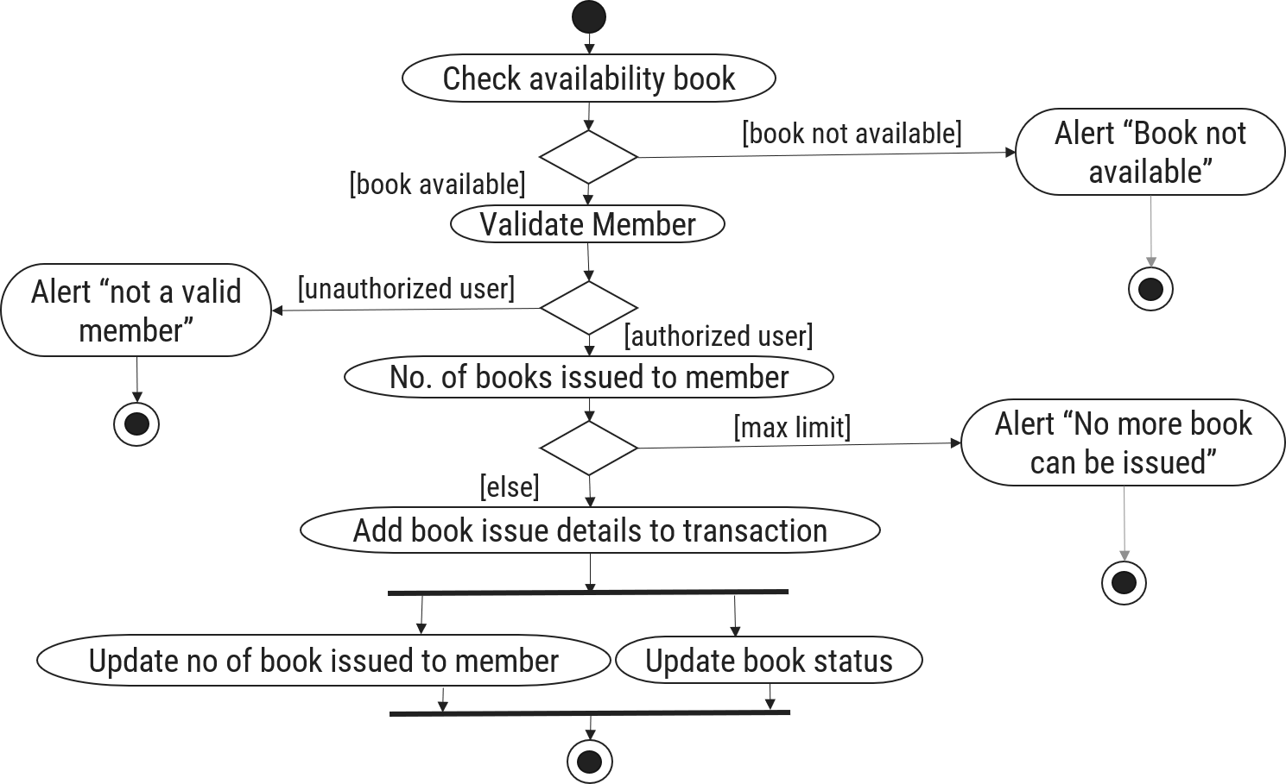
Figure Activity diagram and Swimlane diagram-2 Activity diagram for Book Issue

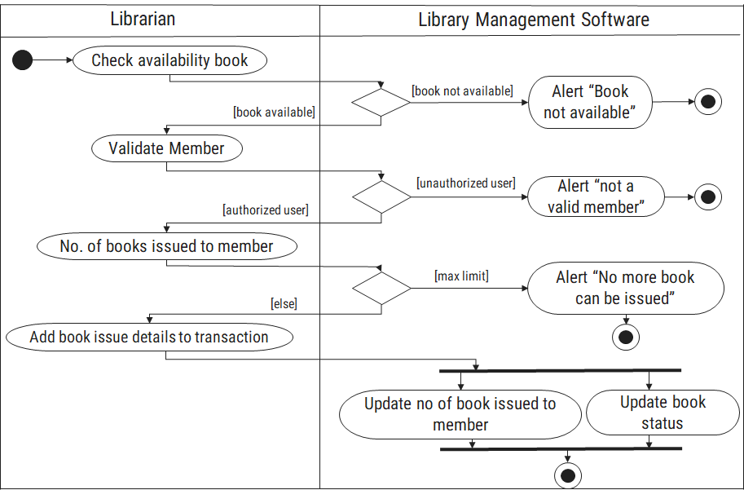
Figure Activity diagram and Swimlane diagram-3 Swimlane diagram for Book Issue

Sequence diagram

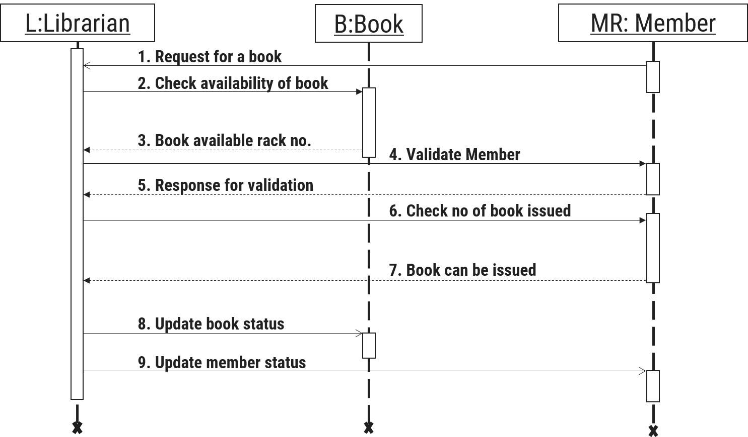
Figure Sequence diagram-4 Sequence diagram for Book Issue

State diagram

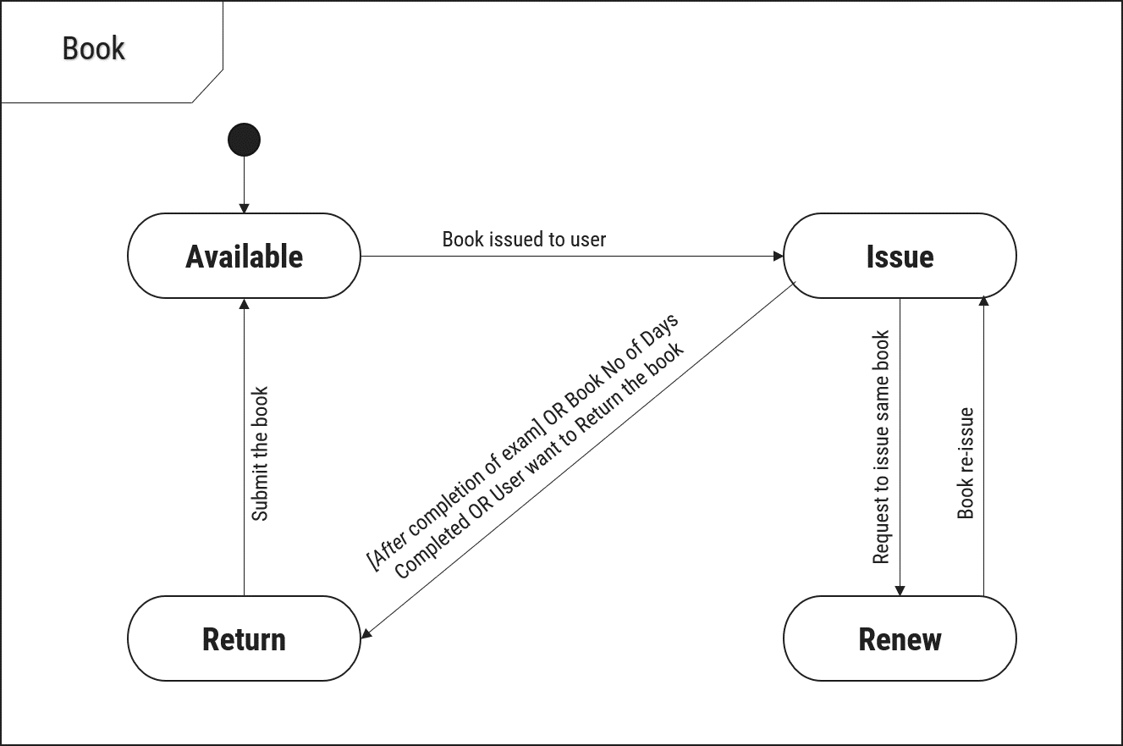
Figure State diagram-5 State diagram of Book

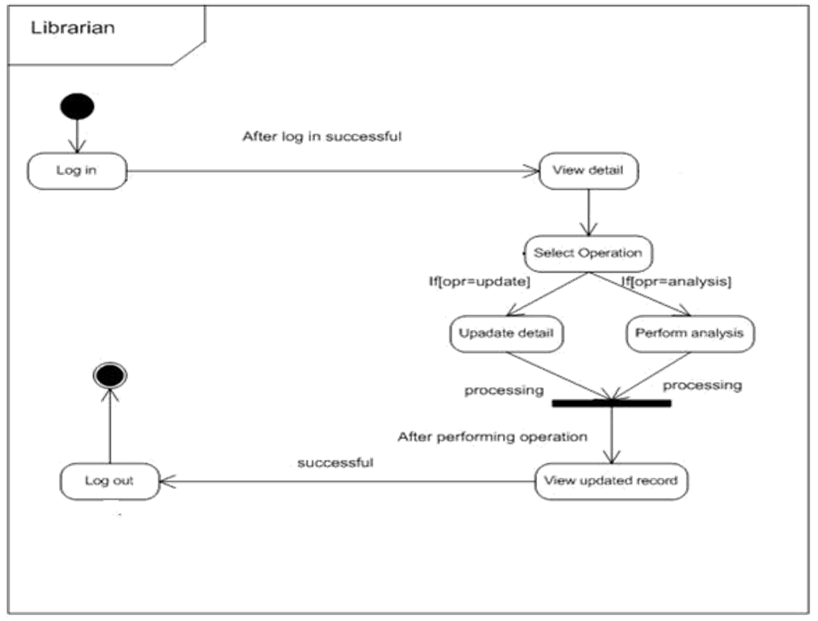
Figure State diagram-6 State diagram for Librarian

Class diagram

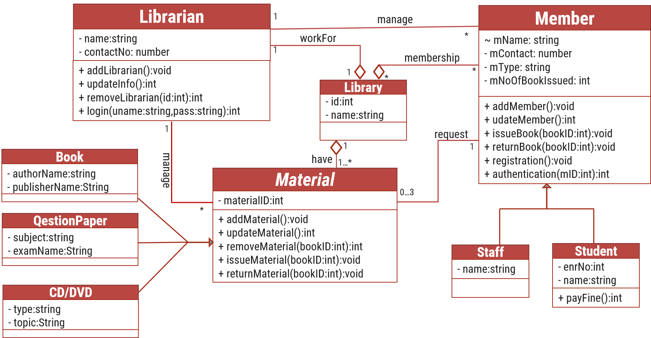
Figure Class diagram-7 Class diagram for Library management system

Data flow diagram

Context diagram (level-0)
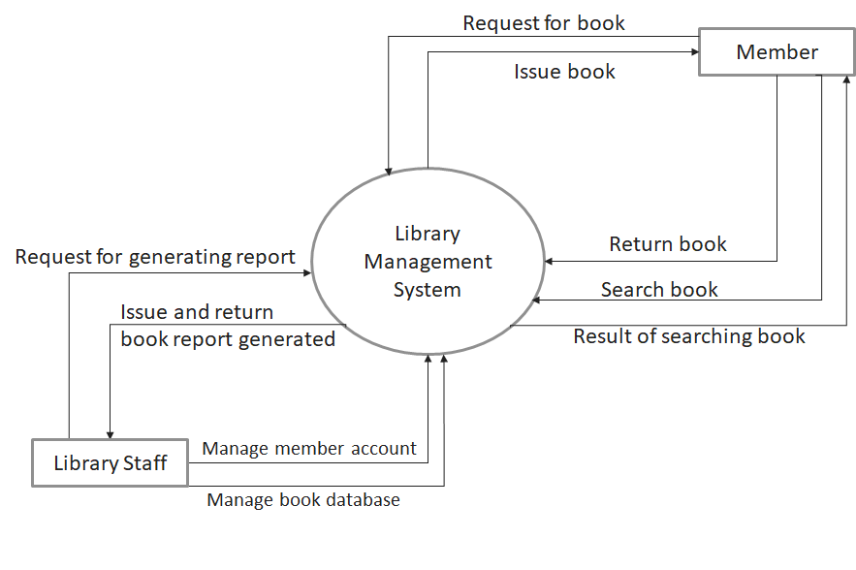
Figure Data flow diagram-8 Context diagram for Library management system

DFD Level-1
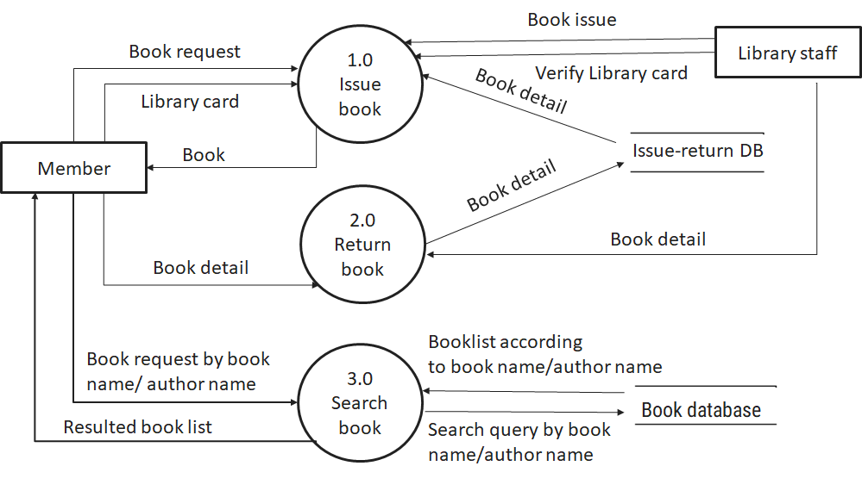
Figure Data flow diagram-9 DFD level-1 for Library management system

DFD Level-2
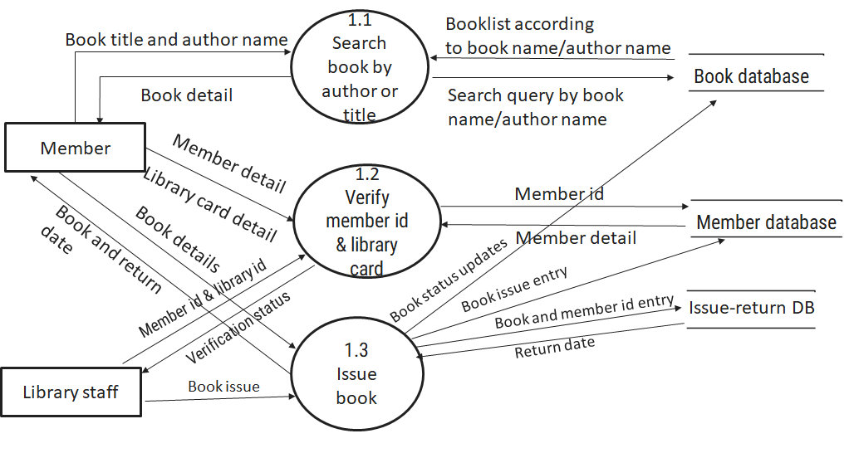
Figure Data flow diagram-10 DFD level-2 for Issue book

External interface requirement (Screens)

Screen-1: Registration Form
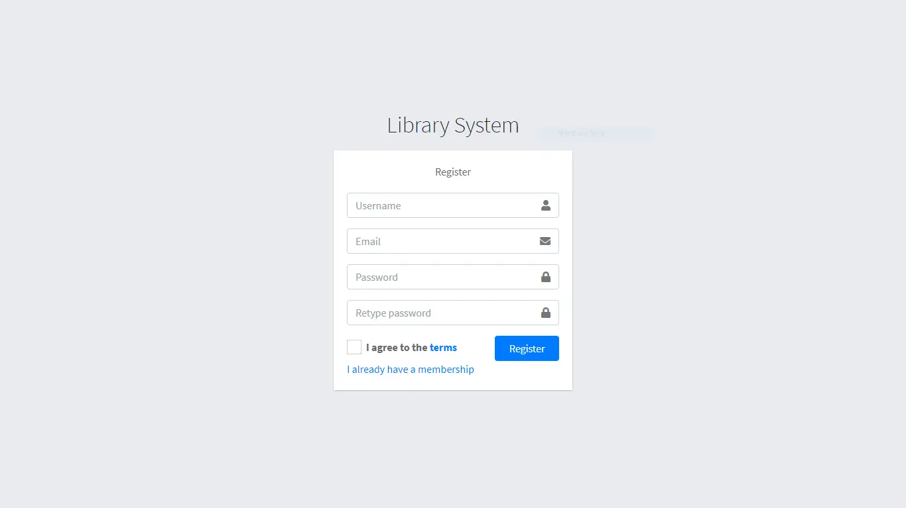
Figure Screen-1: Registration Form-11 Screen-1: Registration Form

Purpose: This form will allow the target end-users to register in the system. To register , the following information will be encoded in the system.

Table Screen-1: Registration Form-1 Screen element of Registration form
Sr. | Screen Element | Input Type | O/M | 1/N | Description
1 | Username | Textbox | M | 1 | Username field should be editable and accept the Username.
2 | Email | Textbox | M | 1 | Email field should be editable and accept the email with proper format.
3 | Password | Password | M | 1 | Password field should be editable and accept the password and display as star or dot.
4 | Retype password | Password | M | 1 | Retype Password field should be editable and accept the password and display as star or dot.
5 | I agree to the terms | Checkbox | M | 1 | Checkbox for accepting terms and condition.
6 | I already have a membership | Link | ------ | ------ | Link for navigate to login page for registered user.
7 | Register | Button | ------ | ------ | Register is a button for store the entered data into database.

Screen-2: Login Form
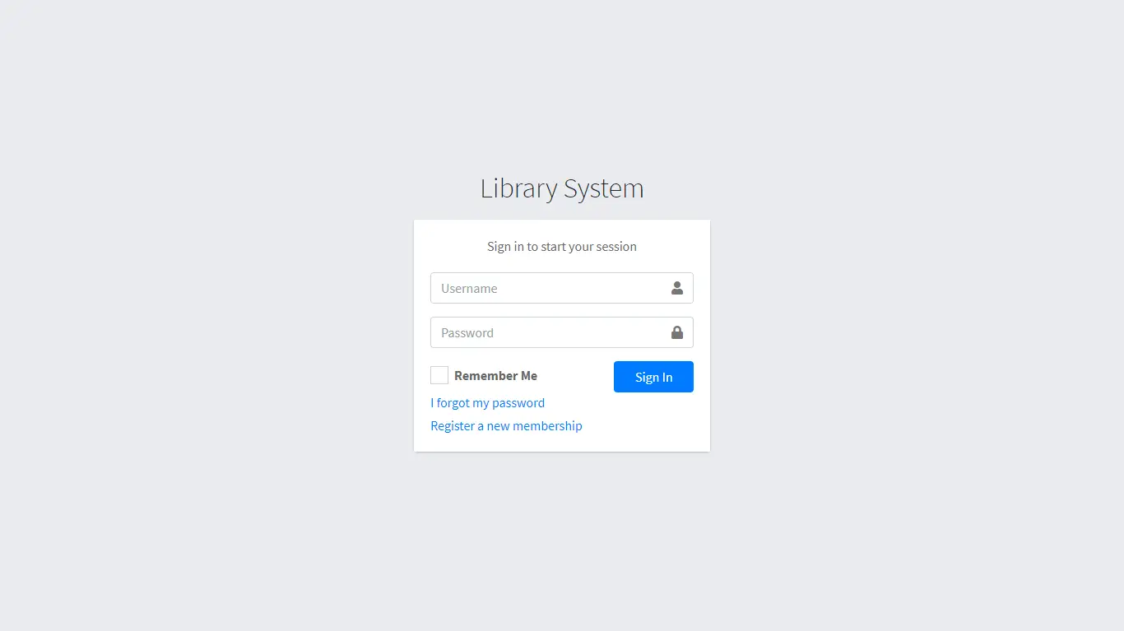
Figure Screen-2: Login Form-12 Screen-2: Login Form
Purpose: This form will be used by the system’s users to access records and features of the system. The users will input the correct combination of their username and password to be able to login to the system.

Table Screen-2: Login Form-2 Screen element of Login form
Sr. | Screen Element | Input Type | O/M | 1/N | Description
1 | Username | Textbox | M | 1 | Username field should be editable and accept the Username.
2 | Password | Password | M | 1 | Password field should be editable and accept the password and display as star or dot.
3 | Remember Me | Checkbox | M | 1 | Saving login credentials through remember me checkbox
4 | I forgot my password | Link | ------ | ------ | Link for navigate to Forgot password page for allows users to recover password.
5 | Register a new membership | Link | ------ | ------ | Link for navigate to membership registration.
6 | Sign in | Button | ------ | ------ | Login button navigates to another page even if valid login credentials.

Screen-3: Add borrower book
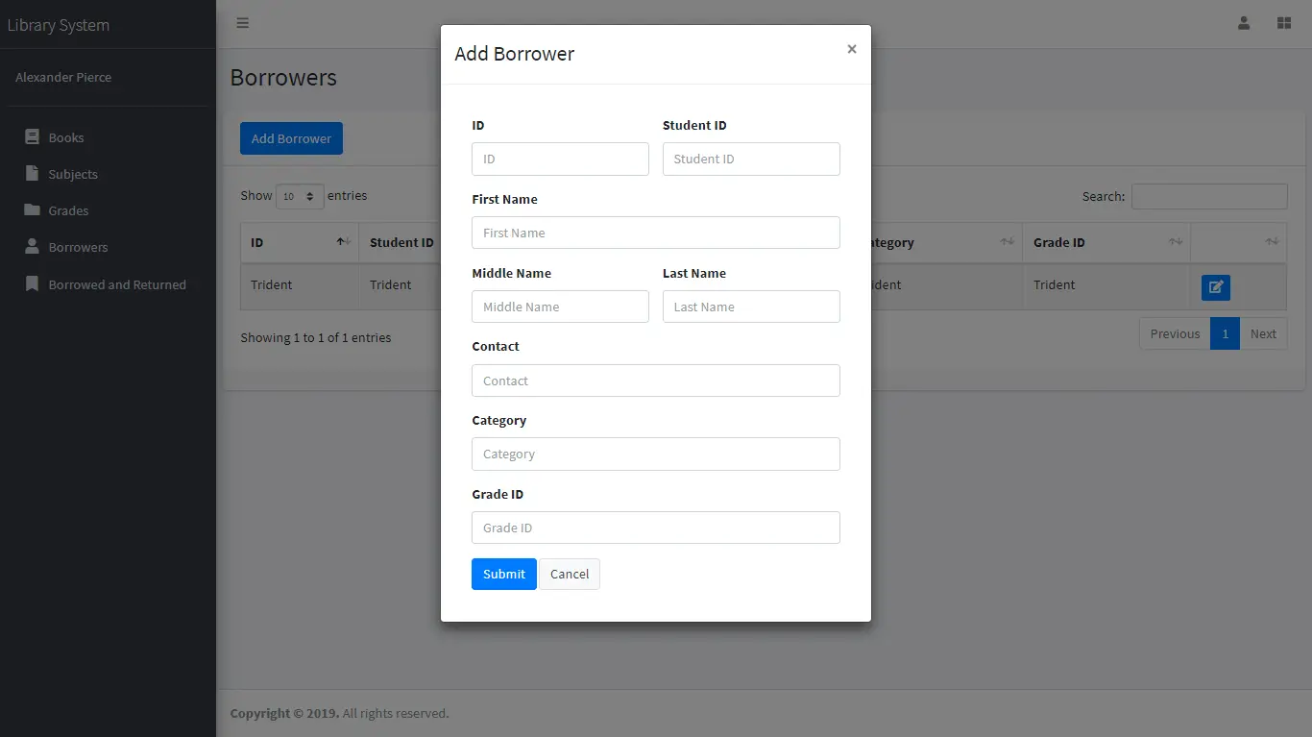
Figure Screen-3: Add borrower book-13 Screen-3: Add borrower book

Purpose: This module will allow the system administrator to add, edit, update or delete borrowers of book. The admin can add borrower information and manage it.

Table Screen-3: Add borrower book-3 Screen element of Add borrower book
Sr. | Screen Element | Input Type | O/M | 1/N | Description
1 | Borrower ID | Textbox | M | 1 | Borrower ID field should be editable and fill autogenerated Borrower ID.
2 | Student ID | Textbox | M | 1 | Student ID field should be editable and accept Student barcode id.
3 | First Name | Textbox | M | 1 | First Name field should be editable and accept only string as a borrower first name.
4 | Middle Name | Textbox | O | 1 | Middle Name field should be editable and accept only string as a borrower middle name.
5 | Last Name | Textbox | M | 1 | Last Name field should be editable and accept only string as a borrower last name.
6 | Contact | Textbox | M | 1 | Contact field should be editable and accept only 10-digit mobile number.
7 | Grade Id | Textbox | O | 1 | Auto fetch detail from the database if proper student id is entered.
8 | Submit | Button | ----- | ----- | Submit is a button for store the entered data into database.
9 | Cancel | Button | ----- | ----- | Cancel is a button for close add borrower dialog.

Database design

List of Tables
- Book
- Borrower
- Student
- Staff

Table List of Tables-4 Table: Book
Column | Data Type | Null | Keys & Constrains | Default Value & Description
BookID | int | NN | PK (Auto Increment)
BookName | varchar(100) | NN
ISBN | varchar(100) | AN
Publication_year | int | AN
Language | varchar(50) | AN

Table List of Tables-5 Table: Borrower
Column | Data Type | Null | Keys & Constrains | Default Value & Description
BorrowerID | int | NN | PK (Auto Increment)
BookID | varchar(100) | NN | FK | Reference of Book Table
BorrowedFromDate | DateTime | AN
BorrowedToDate | DateTime | AN
ActualReturnDate | DateTime | AN
IssuedBy | int | NN | FK | Reference of Student and Staff Table

Table List of Tables-6 Table: Staff
Column | Data Type | Null | Keys & Constrains | Default Value & Description
StaffID | int | NN | PK (Auto Increment)
StaffName | varchar(100) | AN
IsAdmin | Boolean | AN
Designation | varchar(100) | AN

Table List of Tables-7 Table: Student
Column | Data Type | Null | Keys & Constrains | Default Value & Description
StudentID | int | NN | PK (Auto Increment)
StudentName | varchar(100) | AN
Gender | varchar(100) | AN
DOB | DateTime | AN
Department | varchar(100) | AN
Contact | number(10,0) | AN

Stories and Scenario

Story-1: Add New Book in Library Catalogue

Story # S1 | : | As a Librarian,  I want to add a new book in library catalogue  So that everyone can easily find and borrow it.
Priority | : | High
Estimate | : | XL
Reason | : | The addition of a new book to the library catalogue is crucial for ensuring that the library's collection is up-to-date and accessible to everyone.

Scenario# S1.1
Scenario# S1.1 | : | Adding a New Book with Valid Information
Prerequisite | : | Librarian is logged in to the Library management system.
Acceptance Criteria | : | Given: The Librarian is navigated to the library catalog management page. Valid book information, including title, author, ISBN, and other relevant details is added.  When:  The librarian selects the "Add New Book" option  And The librarian enters valid book details  The librarian clicks the "Save" button to add the book to the catalog.  Then the system successfully adds the book to the catalog and the librarian receives a confirmation message with the book's identification number.

Scenario# S1.2
Scenario# S1.2 | : | Adding a New Book with Invalid Information.
Prerequisite | : | The librarian is logged into the library management system.
Acceptance Criteria | : | Given: The librarian is on the library catalogue management page  When: The librarian selects the "Add New Book" option and the librarian enters an incomplete or incorrect book details and librarian clicks the "Save" button to add the book to the catalogue.  Then the system displays error messages for the incorrect or missing information and the book is not added to the catalogue.

Scenario# S1.3
Scenario# S1.3 | : | Attempting to Add a Duplicate Book
Prerequisite | : | The librarian is logged into the library management system and the librarian is on the library catalogue management page
Acceptance Criteria | : | Given: The book information, including title, author, ISBN, and other relevant details, is available and the book with the same ISBN is already in the catalogue.  When: User Clicks on “Add book” button. Enter a number of copies with the same book detail mentioned in the field.  Then: Generate unique book id, barcode and spine label for various book of same title.

Story-2: Search Book
Story # S2 | : | As a Librarian or member,  I want to search for books by title, author, or keyword,  So that I can quickly find books that match my interests.
Priority | : | High
Estimate | : | M
Reason | : | Implementing a search functionality is essential for enhancing the user experience, as it allows librarian and member to efficiently discover and access the library's resources.

Story-3: Manage due date for borrowed book
Story # S3 | : | As Librarian,  I want to manage due dates for borrowed books  So that I can ensure that books are returned on time and avoid overdue fines.
Priority | : | High
Estimate | : | M
Reason | : | Proper due date management is crucial for maintaining the library's collection and ensuring that books are available for all members.

Story-4: Renew book
Story # S3 | : | As Librarian,  I want to renew a book that I have borrowed  So that I can extend my borrowing period if needed.
Priority | : | Medium
Estimate | : | M
Reason | : | Book renewal functionality is a convenience feature for librarian, allowing them to keep a book for an extended period if no one else has requested it.

Story-5: Generate a report on book usage and availability
Story # S3 | : | As Librarian,  I want to generate reports on library usage and book availability  So that I can make informed decisions about library’s books.
Priority | : | Medium
Estimate | : | L
Reason | : | Reporting functionality helps librarians track the usage of library resources and make data-driven decisions to improve services and collections.

Test cases
Project Name: | EMI Calculator | Test Designed by: | P. U. Jadeja
Module Name: | Login | Test Designed date: | 01-10-2023
Release Version: | 1.0 | Test Executed by: | R. B. Gondaliya
 |  | Test Execution date: | 15-01-2023

Pre-condition: Web application should be accessible
Test Case ID | Test Title | Test Type | Description | Test Case ID
TC_001 | Login to web application with valid credential | Functional | Login to Library management system web application through valid credential | TC_001
TC_002 | Login to web application with invalid credential | Functional | Login to Library management system web application through invalid credential | TC_002
TC_003 | Varify login page elements | GUI | varify that all elements are availabe on login page | TC_003

Test Case Title | Login to web application with valid credential
Test Type | Functional
Test Priority | High
Pre-condition | Web application should be accessible

Test Step | Test Case Description | Expected Result | Actual Result | Status | Comment | Data | BUG ID
1 | Access Web application URL | The site launched properly | Site launched successfully | Pass |  | https://accounts.google.com/ServiceLogin
2 | Enter valid Username in username field | Username field should be editable and accept the Username | Username input accepted | Pass |  | Username:  Rbgondaliya@gmail.com
3 | Enter valid Password in Password field | Password field should be editable and accept the password and display as star or dot | Password input displayed in dot and accepted | pass |  | Password:  rbgondaliya
4 | Enter valid captcha code in captch field | Captch field should editable and accept captcha and captcha is case sensitive | Captcha input accepted | Pass | Step required when human action validation perform | get captcha from image which is near by captcha field
5 | Click on login button | User should login into site and navigated to dashboard | User navigated to dashboard and username should br display in top of the right side. | pass

Test Case Title | Login to web application with invalid credential
Test Type | Functional
Test Priority | Medium
Pre-condition | Web application should be accessible

Test Step | Test Case Description | Expected Result | Actual Result | Status | Comment | Data | Bug ID
1 | Verify that User is not able to Login with invalid Username and invalid Password | Should be display an error message enter wrong username or password | Display an error of wrong username and password | Pass
2 | Verify that User is not able to Login with Valid Username and invalid Password | Should be display an error message enter wrong password | Display an error of wrong password | Pass
3 | Verify that User is not able to Login with invalid Username and Valid Password | Should be display an error message User not found | Display an error Username not found | Pass
4 | Verify that User is not able to Login with blank Username or Password | Set required field validation message for Username and Password | Display an error of wrong username and password | Fail | Not performa a validation function fix it |  | Bug_002

Test Case Title | Varify login page elements
Test Type | GUI
Test Priority | Medium
Pre-condition | Web application should be accessible

Test Step | Test Case Description | Expected Result | Actual Result | Status | Comment | Data | Bug ID
1 | Launch application with the given url | The site launched properly | Site launched successfully | Pass |  | https://accounts.google.com/ServiceLogin
2 | Verify that the login screen contains elements such as Username, Password, Sign in button, Remember password check box, Forgot password link, and Create an account link. | All listed control displayed properly on the page | Login page loaded successfully | Pass
3 | Verify that cursor is focused on “Username” text box on the page load | Cursor is focused in Username textbox | Cursor focus in Username textbox | Pass
4 | Verify that tab functionality is working properly or not | When tab pressed cursor move in next control | Cursor moving in next control | Pass
5 | Verify that all the fields such as Username, Password has a valid placeholder | All text fields have proper placeholder | All text fields have proper placeholder | Pass
6 | Verify that the labels float upward when the text field is in focus or filled (In case of floating label) | When field is focused or filled, label display on top of the filled | When field is focus or filled, label display on top of the filled | Pass | step required when fields with floating label
7 | verify that forgot password link working properly | when click on forgot password load forgot passworg page | forgot password link not working | Fail

References

- http://www.w3schools.com/html/html_intro.asp
- https://www.w3schools.com/php/default.asp
- https://www.javatpoint.com/uml

